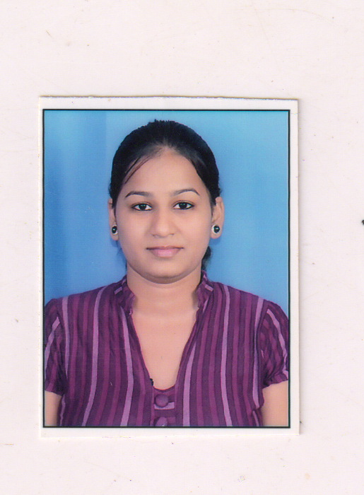
Curriculum Vitae

PALLAVI SINGH
Electrical Engineer
Mob. – +8285786584
E-mail: pallavi.imsec@gmail.com

Career Objective
To work with a learning organization, this would provide me with an opportunity to enhance my knowledge and skills for individual as well as organizational development. in the field of manufacturing, Designing, production or construction work. Intend to build a career with leading corporate company in Hi-tech environment with committed & dedicated people, which will help me to explore myself fully and realize my potential.

Key Skills
- Design and Engineering for lighting and power layouts for housing, commercial, hotels and residential buildings
- Proficiency in Auto CAD (2D &3D), MS Word, Excel & Power Point.
- Knowledge of ETAP Software.
- CGLUX , HAVELLS LIGHTING ,DIALUX SOFTWARE.
- Prepare drawing after site survey as actual.
- Excellent problem solving and documentation skills.

EDUCATIONAL PROFILE:

Qualification | College/School Name | University/ Board | Year Of passing | DIVISON
Degree | Institute of Management Studies & Engineering and College, Ghaziabad. | UPTU | 2011 | FIRST
+2 | C.C.D.P.S, Ghaziabad | C.B.S.E | 2007 | FIRST
XTH | C.C.D.P.S, Ghaziabad | C.B.S.E | 2005 | FIRST

Organization ;

Organization | Designation | Duration
U S CONSULTANTS | Electrical Design Engineer | OCT 2017 till date
QREO INDIA (Sweden Based Company | Electrical Design Engineer | JAN 2017 TO AUG 2017
Analyst Consultants | Electrical Design Engineer | Jan 2014 to JULY 2015
CROWN APPLIANCES & ELEMENTS PVT LTD. | Quality Control & Production Engineer | Oct 2011 to Dec. 2013

PastJob Profile:- | - Responsible to manufacturing components as per QC requirements.  - Prepare Quality documents at every Inspection Stage.  - Final Inspection Report Preparation.  - Responsible for Monthly Production Plans.  - Responsible for high-volume design and drafting of AutoCAD drawings.  - Perform AUTOCAD design, interpreting markups and generating accurate drawings.  - Preparation of Electrical Load Schedule, Preparation of electrical distribution single line diagram (SLD).  - Cable sizing for LV system , Voltage drop calculations.  - Bus duct sizing and calculations .UPS & Battery selection, capacitor bank selection.  - Creating drawings of residential and commercial systems using AutoCAD software.  - Electrical design experience in the engineering service like: Office, Residential, Commercial.  - Design of light current system(data system, telephone system, fire alarm system, Nurse call system , CCTV, access door system and sound system  - Identified existing design problems and recommended changes.  - Responsible to both the Project Manager and the Senior Engineer/Technical Manager for the organization, production, and quality of work
CORE RESPONSIBILITIES | - Creating List (BOQ) of various Electrical Designing Components for a project.  - Excellent Knowledge of Autocad Software.  - Knowledge of Terminologies & ability to read and understand engineering drawings.

PROJECTS HANDLED:

- Nursing Home Building, At Karnal .
- Karuna Sagar Valmiki Tirth Sansthan, At Amritsar.
- Gurgaon Housing At Gurgaon.
- V.I.P floors (DMRC) At Gurgaon.
- M.M.C Hospital (Muzaffarnagar).
- St. Marks School, Faridabad.
- Shri Guru Gobind Singh College of Commerce(Girls Hostel).
- Shivam Motors.(Car Showroom)
- Ahuja Radios.(Factory)
- Interior Project.(Airtel Showroom etc)

TRAINING:

- Two Month’s Diploma in “Electrical Power System Designing” from Advance Electrical Design And Engineering Institute, An ISO approved.
- One month Training in Inverter & UPS manufacturing & Servicing By RUDSET Institute (Govt. Training Program Sponsored By Canara Bank, Syndicate bank & SDME TRUST).

Personal Profile

Father’s Name : Mr. Ajitendra Vijay Singh
Date of Birth : 15 Feb 1990
Sex : Female
Marital Status : Unmarried
Hobbies : Interacting with People, Watering plants
Language Known : English & Hindi
Notice Period : One month
Passport : Yes

Date………
Place………… (Pallavi Singh)

